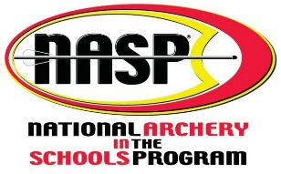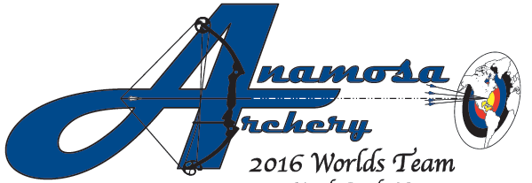
🎯 Join the Anamosa Archery Club for our 2025–2026 Season Kickoff Meeting!
Are you a student in grades 4–12 with an interest in archery? Come learn more about the Anamosa Archery Club at our informational meeting:
📅 Tuesday, October 28th
🕡 6:30 PM
📍 Anamosa Middle School Choir Room

Why Join Anamosa Archery?
🏆 Home of Champions
Our club proudly includes the current Iowa Bullseye Champion and more Top-10 State archers!
🎓 Experienced Coaching
All coaches are BAI-certified, ensuring safe, structured, and skill-building instruction.
💰 Affordable & Accessible
Thanks to a generous NASP grant and community sponsorships we keep costs low and provide bows for use during the season—no need to buy your own gear!

Archery Builds More Than Skill
Participating in archery helps students develop:
- 🎯 Focus & concentration
- 💪 Strength & coordination
- 🧘 Confidence & relaxation
- 🏃‍♂️ Physical fitness
- 🧠 Goal-setting & discipline

What Educators Are Saying
“Archery is the only sport I’ve seen that is this structured. Kids learn to wait their turn, follow directions, set goals and challenge themselves… Archery develops character, and these students will benefit the rest of their lives.”
— Wyatt Kingston, Recreation Specialist, Richmond, VA
“Archery gives a place to belong to kids who aren’t involved in other school activities.”
— Jason Anderson, Teacher, Allen High School, TX

We’d Love to See You There!
If you can’t attend the meeting but want more info, feel free to reach out:
📧 kimberly-keister@uiowa.edu

